Craneswater Group Practice Friends and Family Test – June 2024

We ask our patients the simple question of - would you recommend the service to your friends and family - and provide the following option answers:

|  |  |  |  |  |  |
| --- | --- | --- | --- | --- | --- |
| **Very Good** | **Good** | **Neither** | **Poor** | **Very Poor** | **Don’t Know** |
|  |  |  |  |  |  |

The response for **June 2024** is as follows:

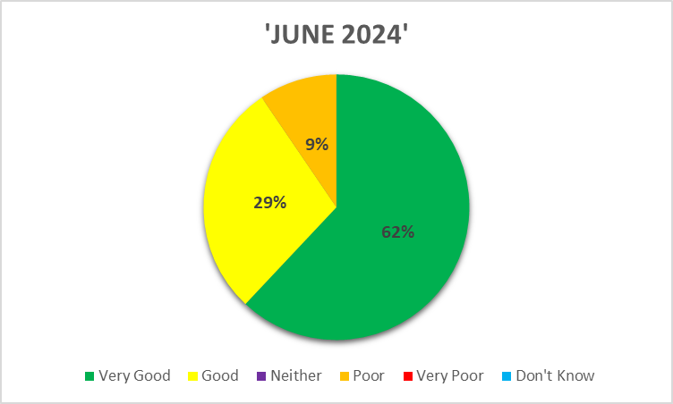

Of all the patients who provided a response

**91%** stated they would recommend the service